

SEMINAR
SEMESTER : 1 - 2017/2018

COURSE CODE : MANB1113

COURSE : DATA GOVERNANCE

PROGRAMME : MSc (BIA)

SUBMISSION DATE : 17 DECEMBER 2017

PREPARED BY : 1. AHMAD NIZAM MOHD LAZIM MAN171058
2. AMJAD ALASSEH MAN171009
3. MUHAMMAD NIDZAM BIN MASO’OD MAN171043

SUBMITTED TO : DR DORIS WONG HOOI TEN

Data Governance Office function inside a Data Governance Framework

Ahmad Nizam Mohd Lazim, Amjad Al Asseh Muhammad Nidzam Maso’od
Advance Informatics School (UTM AIS)
nizam1973@graduate.utm.my
alassehamjad@graduate.utm.my
masood@graduate.utm.my

Abstract- The purpose of this paper is to discuss on the function Data Governance Office inside a Data Governance Framework. In this paper, the authors will explained briefly on the definition and details of Data Governance Framework and for Data Governance Framework. After explaining on the definition and details, the authors explained on the function and relationship between Data Governance Office and Data Governance Framework. By identifying these factors, it will help organization with intend to create a Data Governance Office and eventually drive the success of their Data Governance Framework.

Keywords - . Data Governance, Data Governance Office, Data Governance Framework, Data management,

I. Introduction
In the twenty-first century, business are increasingly being base based on data. Large enterprise are beginning to realize the inherent data value that they possesses and the need to have a control on the data and managing it as an enterprise asset. This can be execute by implementing data governance in their organization that will manage the authority, responsibility and tasks in all aspect of data management [1].

Data Governance by definition is the exercise of decision-making and authority for data-related matter [2]. It is also can be define as controlling and managing a convergence of several areas of data management such as data quality, systems, data security, and data administration aspects throughout the organization [1]. Data Governance Institute (DGI) defined it as “Data Governance is a system of decision rights and accountabilities for information-related processes, executed according to agreed-upon models which describe who can take what actions with what information, and when, under what circumstances, using what methods.” [3] It is being defined in DMBOK as "The exercise of authority and control over a process, organization or geopolitical area. The process of setting, controlling, and administering and monitoring conformance with policy.” [4].

By implementing Data Governance within an organization, it can help align the data stakeholder’s needs and providing checks-and-balance process between data creation or data collecting groups, the consumer of the data or whom that analyze the data, and also other various stakeholder groups [5]. In order to implement a successful Data Governance within an organization, we need a structure on how we want to govern. We also need a driver that will help us to navigate those structures. In Data Governance, these will be translate into a Data Governance Framework that will be the structure of Data Governance, and Data Governance Office as the driver.


Fig. 1 Building a framework

In this paper, the authors will discuss more on Data Governance Framework and Data Governance Office in the next few chapters and explain the function of Data Governance Office within the Data Governance framework. For Data Governance Framework, the authors will based the explanations using the Data Governance Institute (DGI) Framework.

DGI was founded in 2003 by Gwen Thomas and currently the industry’s oldest and best known sources of Data Governance best practices and guidance. Their Data Governance Framework was introduced in 2004 and has since been used by data practitioner to implement Data Governance within their organization.
II. Data GOVERNANCE FRAMEWORK
- Definition of Data Governance Framework

Frameworks is the structure or backbone that form the base of a system. It help us to arrange how we contemplate convoluted or questionable ideas. By establishing a framework, it would enable us to accomplish clearness of thought and reason of the system. A structure can likewise enable you to prevail with regards to acknowledging an incentive from your program and endeavours and information. [2].

The benefits of having a Data Governance Framework are, it can help the organization implementing it to increase revenue and also the value of the organisation. The organization with Data Governance Framework in place will have a viable structure in terms of relationship with customer and supplier thus can help to establish a good reputation which in the long run help to gain customer trust and this eventually bring an increase of revenue to the organization and increase the value of the organization in the public eyes. This will also reduce the complexity of processes within the organization. Data Governance Framework can also help in managing risk and securing vulnerabilities in term of regulation compliance, enhancing securities and ensuring privacy [2]. Design of Data Governance Framework can help to clarify data related definition, ensuring no wastage of time, making sure tasks are easier to comprehend, tasks are focus and maintained, setting up accountabilities and characterize quantifiable triumphs successes [2].

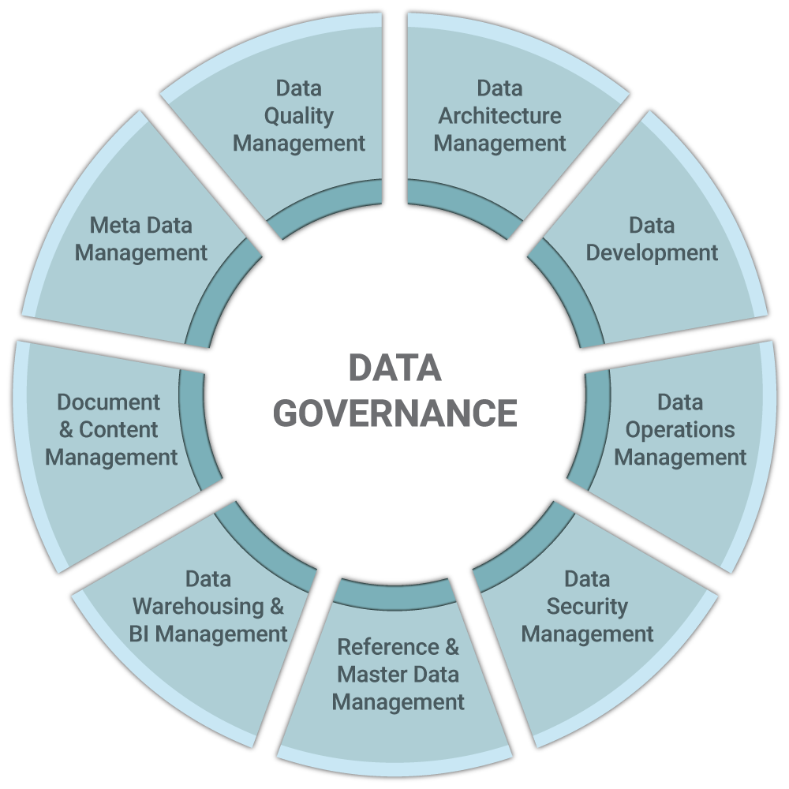
Fig 2: Data Governance [ascention.com]

- Organizing Data Governance Framework

It is vital that Data Governance Framework to be organized at the start of the Data Governance Program. This is to lay a foundation on how we want the shape of the Data Governance Framework to look like. Common ways to organize a framework is to use the 5Ws pattern which are WHO, WHAT, WHEN, WHERE, and WHY.

Table 1: 5Ws
Pattern | Usage example
WHY | Why we should do Data Governance Program?
WHAT | What is the benefit of doing Data Governance?  What we want to accomplish by doing Data Governance?
WHO | Who will be involved in Data Governance Program?  Who should be include in Data Governance Program?
HOW | How we are going to implement Data Governance Program?  How the Stakeholders will work together to implement Data Governance Program?  How we will get funding to start Data Governance Program?
WHEN | When should they start performing specific processes?

- Data Governance Program Lifecycle

In order to design a Data Governance Framework successfully, we need to understand the life cycle of a Data Governance Program.

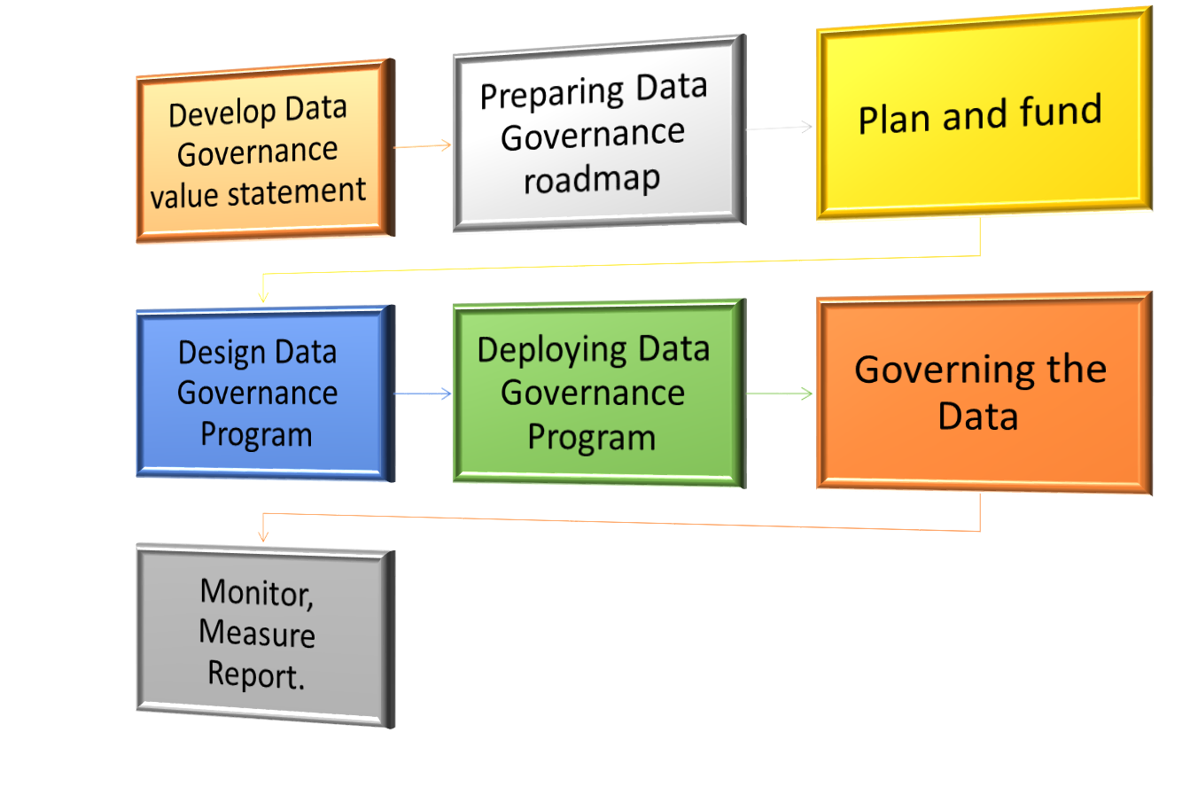
Fig 3 Data Governance Program lifecycle

Data Governance Program Lifecycle steps and explanations are as in below table.

Table 2: Data Governance Program Lifecycle
Steps | Explanations
Value statement | Need to include how it can help the organization to make money, accomplishing missions, increasing value of assets, managing cost, reducing complexity, and supporting other efforts such as in security.  Approach in creating value statement  If we do A, then we can expect B, which should lead to C.
Data Governance Roadmap | Takes account into what drive the Data Governance Program and what is the constraints in implementing Data Governance Program.
Plan and fund | Create a high-level planning and promote the plan. By promoting the plan, it will help to secure funding.
Design Data Governance Program | Design the Data Governance Program using Data Governance Framework. Discussion must be initiate with major Stakeholders on the input for Data Governance Program design.
Deployment of Data Governance Program | Data Governance Program need to be deploy stage by stage. An aggressive deployment will result in rejection within organization. It is better to target low hanging fruits first where we can achieve the result faster. This will then be promote across the organization to achieve acceptance.
Governing the data | Data need to be govern according to standards and policies that has been set during earlier stage of Data Governance Program design.
Monitor, Measure, Report | Results from implementation of Data Governance plan are monitor, measured and reported to justify the need of a Data Governance Program.

- Data Governance Framework structure

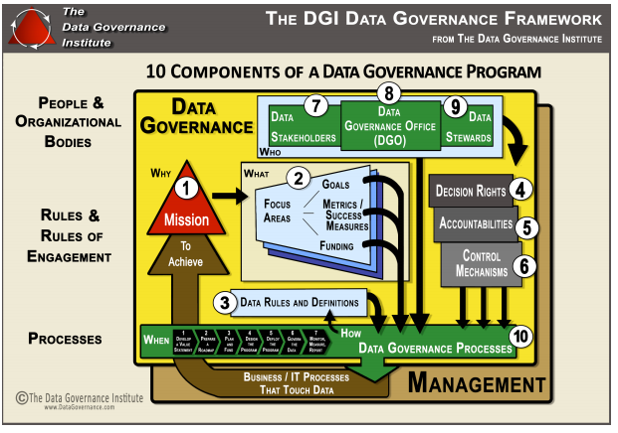
Fig. 4 DGI Data Governance Framework

The components inside a Data Governance Framework are categorized as below.

- Rules and Rules of Engagement
- People and Organizational Bodies
- Processes

In order to successfully implement Data Governance within an organization, these components are needed. These 3 categories are interrelated with each other’s where 1 category cannot successfully by implemented without the other category.

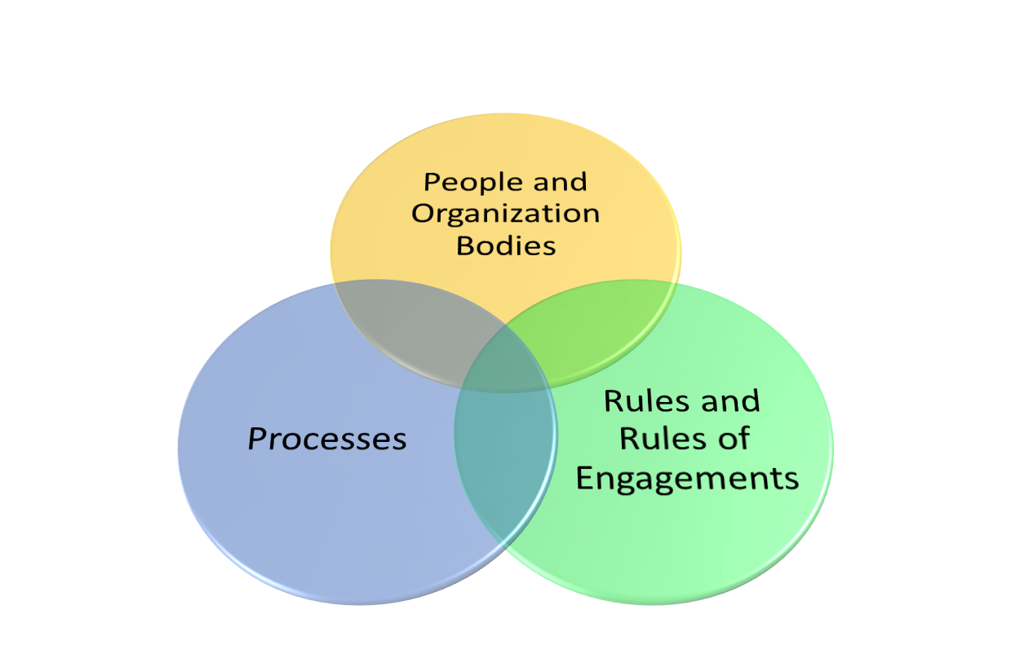
Fig. 5 Data Governance Framework components relationship.

Rules and Rules of Engagement

These components focus on the strategy of managing Data Governance within an organization. It will involve more on what is the target to achieve and what is the outcome desired by implementing Data Governance Program.

Table 3: Rules and Rules of Engagement components
Components | Details
Mission and Vision. | Data Governance mission will consists of defining and aligning the governance rules, ongoing services to the data stakeholders, and proactive rules in order to react and resolve any arising issues.
Goals, Governance Metrics and Success Measures, and Funding Strategies. | Goals for Data Governance should include on how Data Governance could help to increase revenue and value, reducing or controlling cost and process complexity, and managing risk and vulnerabilities. Other criteria that can be included in goals are specific goals, measureable target, actionable item, relevant target and timely execution.
Data Rules and Definitions | Data Rules and Definitions need to be aligned to policies, data standards, compliance standards, business rules and the definition of the data. Activities that can be done to establish this component within the framework are giving definitions and creating rules, auditing current rules and definitions, finding and solving gaps, aligning and prioritizing rules and definitions and formalize rules after definition has been establish.  Examples of data-related rules are as below;  - Policies  - Standards  - Guidelines  - Requirements  - Guiding Principles  - Business Rules  - Data Quality Rules  - Data Usage Rules  - Data Access Rules
Decision Rights | Decision right need to be define before any Data Governance implemented. ”Who” should be used to identify the roles of decision makers.
Accountabilities | Accountabilities of Data Governance should be define in order to avoid confusion. Without this component, our Data Governance will be in chaos since nobody will be in charge to monitor, implement or taking ownership of a process. In order to define Accountabilities question such as “Who should do?” or “When should” can be used.
Controls | Data risk and vulnerabilities will be always exist. In order to mitigate this, we need to have a data-related control across the organization. This can include access to the data, process change, ownership of the data, etc.

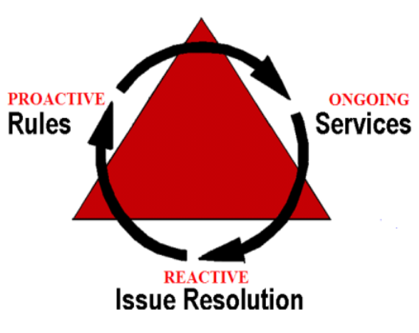
Fig 6 Data Governance Mission and Vision

People and Organizational Bodies

These components are about managing the individuals and groups that are involved in data related matters. The focus for these components will be about those that will be steering Data Governance, who serve as the policies and decision-makers and also who will be the implementer of the policies.

Table 4: People and Organizational Bodies components
Components | Details
Data Stakeholders | Data Stakeholders by definition is whoever are involve in data related matters. This will include data creator, data user and also the one who set the definitions and rules for the data. As data are being use across the organization, stakeholders also will involve the personal or groups across the organization.  Examples of Data Stakeholders is as below;  - business groups  - IT Teams  - Data Architects  - DBAs  These Data Stakeholders will sometime be the members of bodies that are being created to govern data such as,  - Data Governance Board  - IT Steering Committee  - Executive team  The best practices when identifying Data Stakeholders is to create a list of Data Stakeholders at the beginning of the Data Governance Program
Data Governance Office (DGO) | Data Governance Office will be the one who will facilitates and supports data-related activities. This component will be the focus of our paper and will be explained in detail in the next chapter.
Data Stewards | Data stewards will be the person or group which make data-related decision. They will also be a part the group that will set the policy and standards.  Below are 3 examples of models for Data Stewards  - Decision maker who serves in a council and involve in policies making process  - Tactical Data Stewards which involve in operation and follow process and policies set by others.  - Hierarchies Data Stewards. Each level of the organization will have its own Data Stewards with different level of power.

Processes

This component will focus on the process within Data Governance Program.

Table 5: Processes components
Components | Details
Proactive, Reactive, and Ongoing  Data Governance Processes | Data Governance process should be standardized. It is also need to be documented and the process need to be repeatable. Process should be designed to be compliance with regulatory and also the requirement for Security, Data management, Access Management, and also the Privacy of the data. Recommended processes for Data Governance is as below:  - Aligning Policies, Requirements and Controls  - Decision Right management  - Accountability management  - Stewardship task  - Change management  - Issues resolutions  - Data Quality requirement details  - Integrating Technology into Governance  - Taking care of stakeholder requirement  - Communications  - Perform measuring and create value report

- Data Governance Framework Challenges

The most challenging part in Data Governance Framework is communication. This communication will include verbal and written communication. There is a need for a body to manage communication between stakeholders and different layers of an organization and this is where Data Governance Office can be very helpful. As written communication is also important, the method can be standardize using report templates, email templates and presentation templates [2].
III. Data Governance OFFICE
- Definition of Data Governance Office (DGO)
Data Governance Office is described as “A centralized organizational entity responsible for facilitating and coordinating Data Governance and/or Stewardship efforts for an organization. “[6]
- Roles of Data Governance Office in Data Governance Program
DGO Team will provide input and supports a decision-making group, such as a Data Stewardship Council. DGO typically organize and encourage endeavors. At times, they take the necessary steps of breaking down and bundling up concerns or matters, so Data Governance Authorities can conclude.
Typically, a DGO incorporates parts that lead interchanges and fill in as contacts to innovation and design groups. An individual from the DGO will commonly keep records of information stewards and other program members. [7]
- Establishing a Data Governance Office
Most companies that commence an official Data Governance and Stewardship exertion require a facilitator to encourage and facilitate exercises of committees, stewards, and project sponsors.
The facilitator might be singular patrons who have been doing this effort casually and will proceed with it. Nonetheless, if the plan to make every effort to roll out enterprise-wide improvements, at that point it most likely needs greater custom. What's more, the individuals who expedite it most likely need a specific level of status inside the company and support from top initiative.
Who be supposed to be part of Data Governance Office team? Obviously, the appropriate response relies upon what we are attempting to fulfill with our agenda. Most Data Governance projects incorporate a qualified person in charge who can explore governmental issues, structure and facilitate meetings, work with team members in the background, brief project sponsors, and ensure work delegations result of project committee meetings are heading in the right direction. The assigned individual may not be a data specialist, but rather they should have the capacity to talk with all project sponsors and to comprehend information streams charts and data models.
Make certain that the project team have the right proficiencies skills in communications and the right tools to work effectively with data stakeholders when initially setting up Data Governance Office. Overall, Data Governance can be politically complex. [8]
- Performing analysis and reviews to make sure that approaches, methods and standards are set up for keeping up/enhancing the program. [9]
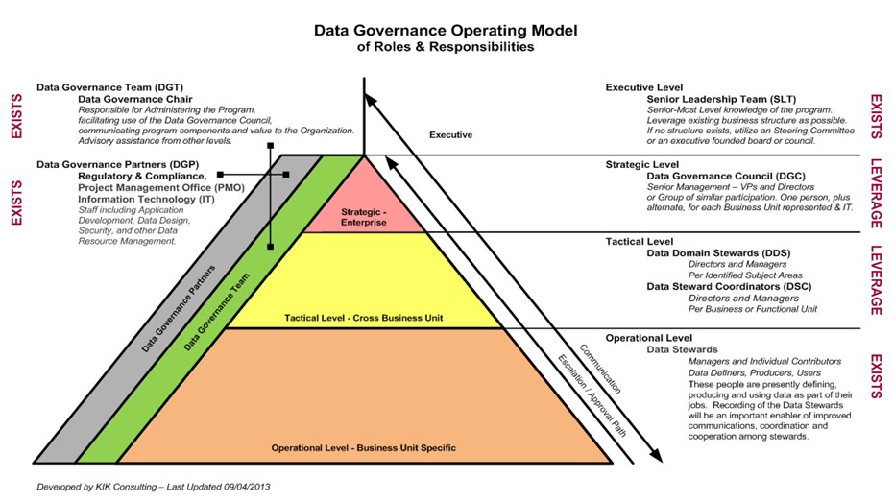
Fig 7 DGO inside a Data Governance Operating Model
IV. Data GOVERNANCE OFFICE FUNCTION INSIDE A FRAMEWORK
Data Governance Office Teams is the first team to be setup within the Data Governance Program; this is due the nature of their roles, which is planning entire program, communication the program between the Data Governance Councils, Stakeholders, Stewards and operational level.
Data Governance Office Team will be the key playmaker within Data Governance Framework Program which executing the Data Governance implementation, responsible for administering the program and facilitating the use of the data. Data Governance Office Team also acts as intermediaries or supporting team to a Governance Councils, which mean they provide feedbacks and inputs to Data Governance Councils. Hence, the success of the entire program dependent on the Data Governance Office Team.
Strategically, Data Governance Office Team is the key team with the most vital roles in a successful Data Governance Framework included but not limited to the following:
- Enabling Data Governance establishment, strategic and Operational Stewards, and the Data Governance Committee participation.
- Cultivating and presenting data governance program including educational program, awareness program, and coaching resources.
- Delivering value guarantee by super visioning, supervising, delivering results to governance committee
By having Data Governance Office Team within the framework, the organization will gain more benefits rather than negative outcome. This is by
- Facilitating in characterizing data quality standards for recurring publication.
- Keeping up data quality matter by examining and remodeling for notable data.
- Performing analysis and reviews to make sure that approaches, methods and standards are set up for keeping up enhancing the program.
V. Conclusion
From this paper, we can conclude the function of Data Governance Office inside Data Governance Framework. They are the one who will be the bridge connecting various level within an organization. They are also the one who will do the “hard jobs” of administrating Data Governance and sometimes function as a Project Manager in the Data Governance Program. Hence, communication skills are very important criteria in Data Governance Office selection. By identifying the function and roles of Data Governance Office inside a Data Governance Framework, we hope it will be a good guidance for any organization with intent to make their Data Governance program a success.
Acknowledgment
We are grateful because we manage to complete this paper within the time given by our lecturer Dr. Doris Wong Hooi Ten. This paper cannot be completed without the effort and co-operation from our group members, Ahmad Nizam Mohd Lazim, Amjad Al Asseh Muhammad Nidzam Maso’od. We also sincerely thank our Data Governance lecturer, Dr. Dr. Doris Wong Hooi Ten for the guidance and encouragement in finishing this paper and also for teaching us in this course. Last but not least, we would like thank our family for the support given.
References
- Begg, C and Caira, T. “Exploring the SME Quandary: Data Governance in Practise in the Small to Medium-Sized Enterprise Sector” The Electronic Journal Information Systems Evaluation Volume 15 Issue 1 2012, (pp03 -13)
- “The DGI Data Governance Framework” The Data Governance Institute. (http://www.datagovernance.com/the-dgi-framework)
- Cited from Data Governance Institute (DGI)
- Cited from Data Management Body Of Knowledge (DMBOK)
- “How To Use The DGI Data Governance Framewok To Configure Your Program”, The Data Governance Institute. (http://www.datagovernance.com/wp-content/uploads/2014/11/wp_how_to_use_the_dgi_data_governance_framework.pdf)
- “Data Governance Office (DGO) Glossary” in Data Governance Institute. http://www.datagovernance.com/glossary-governance/
- “Data Governance Office Roles” in Data Governance Institute. http://www.datagovernance.com/adg_data_governance_roles_and_responsibilities/
- “Establishing a Data Governance Office” in Data Governance Institute. http://www.datagovernance.com/establishing-a-data-governance-office/
- “Complete Set of Data Governance Roles & Responsibilities” in The Data Administration Newsletter (TDAN). http://tdan.com/complete-set-of-data-governance-roles-responsibilities/21589

